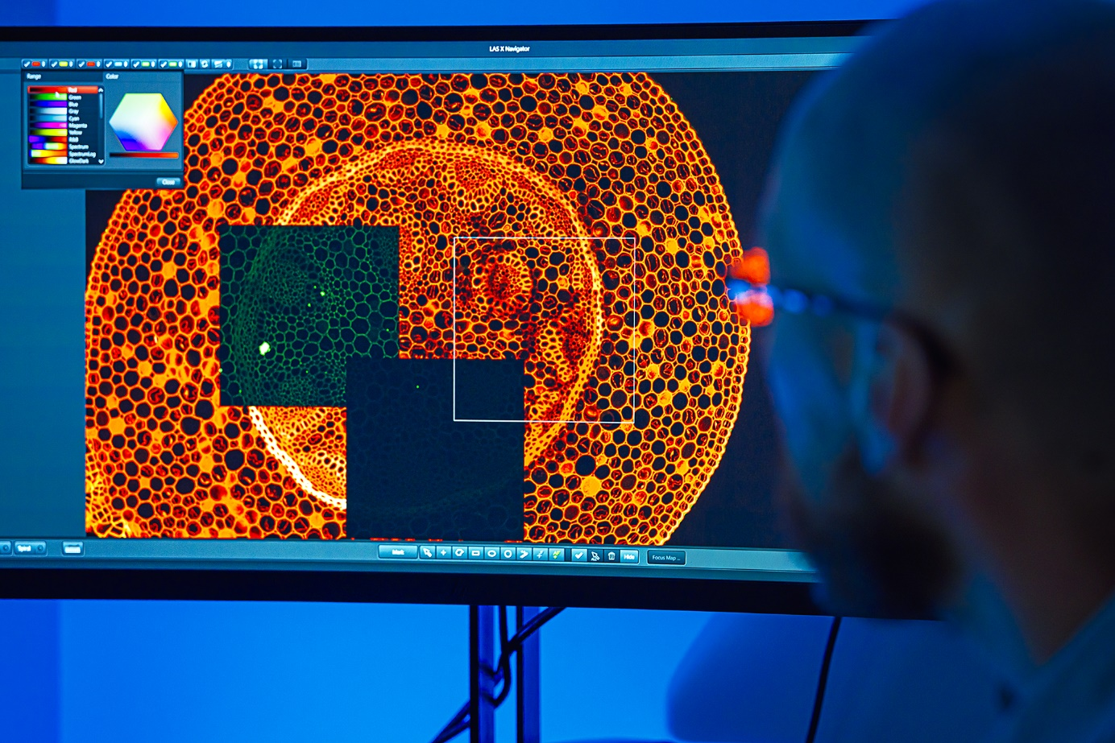

**PhD Student Position**

The Nencki Institute of Experimental Biology of the Polish Academy of Sciences, a part of Warsaw PhD School in Natural and BioMedical Sciences, is currently the largest non-university biological research centre in Poland.

Research conducted at the Institute focuses on issues directly related to health protection and improving the quality of life. The Institute's main mission is to learn the mechanisms and develop innovative therapies and diagnostic methods for cancer, diabetes, neurodegenerative diseases, neurological disorders and other civilization diseases. In addition to basic biological research, the Institute provides expertise in the field of translational research, including pre-clinical research. The Nencki Institute is open to cooperation with industry, aimed at introducing new products to the pharmaceutical, biomedical and biotechnological market.

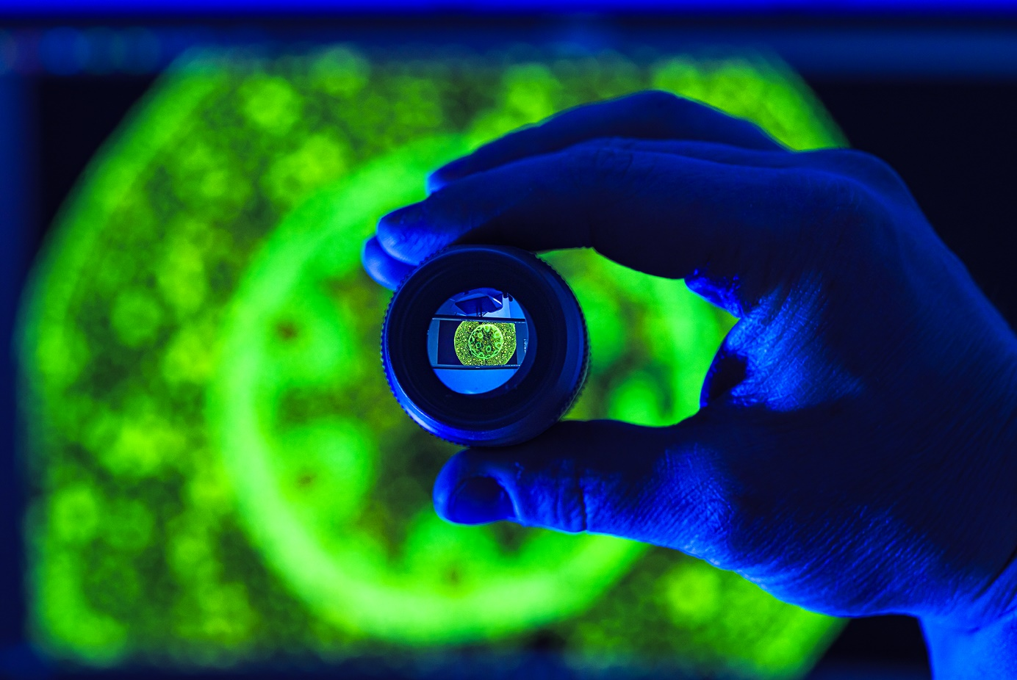

**We are looking for you, if:**

* you are an enthusiastic student with **a strong interest in Life Sciences,**
* you have **a Master’s degree** in biology, biotechnology, biophysics, neuroinformatics, neurocognitive science and other related fields,
* you would like to **develop your carrier** not only in scientific field, but also in the business environment,
* you would like **to focus on research and practical work** with optimal number of classes,
* you want to gain knowledge and skills necessary **to have impact on the world,**
* you want your answer to the question “What is my superpower?” to be **“I’m the scientist!”**



**We offer:**

* **Free of charge** PhD course;
* **Scholarship** agreement;
* **Interdisciplinary education**, the possibility to participate in classes in 4 scientific disciplines: biology, chemistry, physics, and medicine;
* Participation in **international conferences and exchange programmes**, e.g. STER;
* You can **prepare yourself to conduct high-profile research** at academic institutes and research centres in Poland and abroad;
* **Promotion of science**, e.g. Science Picnic, Brain Week;
* **Effective international collaboration** and opportunity to meet leading scientists from Poland and other European countries;
* **Support in applying for additional grants;**
* **Supervision of great scientists**, who have gained experience all over the world;
* Participation in the life of the **scientific community.**

**Why the Nencki Institute of Experimental Biology?**

* We are the part of **Dioscuri Centres of Scientific Excellence**, a programme initiated by the Max Planck Society and managed with the National Science Centre in Poland;
* You don’t need to conduct classes during your PhD course;
* We offer **implemented science solutions for business;**
* Our scientists **publish in established scientific journals**, take part in **scientific contests** and are awarded;
* We have **8 core-facility environmental laboratories**, offering high-class research equipment and expertise, required to conduct advanced investigations in the neurobiology, molecular biology and biological imaging;
* We have the **Research Station in Mikołajki**, located in beautiful surroundings of the Mazurian lakes.

|  |  |
| --- | --- |
| The next admission round will start on **May 20th**  and will last until **June 2nd, 2024.**  More information: [**https://warsaw4phd.eu/en/candidates/admissions/**](https://warsaw4phd.eu/en/candidates/admissions/) | E:\Users\Dszymanska\Desktop\studia doktoranckie\Szkoła doktorska Warsaw-4-PhD\logo i papier szkoły\Warsaw 4 Phd eng horizontial.jpg |